# Ising Model

The Ising Model was initially developed in the field of Statistical Physics as a model of ferromagnetic phase transitions in certain types of metals, such as iron and nickel. It is a type of Interacting Particle System, in which the macro behavior of the system is the result of the microscopic behavior of the system.

At risk of oversimplifying, a phase is a certain “macro state” of the system which behaves in some way that is significantly different than other phases. A familiar example is how water can exist in 3 phases: liquid, solid (ice), and gas (steam). Which phase the system is dictated by the parameters of the system. For example, water’s phase is determined both by the air pressure and the temperature. At 1 ATM, water freezes (transitions to its solid phase) at exactly 0 degrees Celsius, transitions to its gas phase at precisely 100 degrees Celsius, and is in its liquid phrase when the temperature is strictly between those two temperatures.

The microscopic behavior of the system refers to the behavior of the smallest possible unit of the system. For example, the smallest unit of water is an individual atom. Thus, the overall phase of the water is determined by the sum of the behaviors of the individual atoms.

In the case of the model of ferromagnetic phase transitions, paramagnetic materials like nickel and iron exhibit differing magnetic behavior depending on their temperature. The specific temperature at which the phase transition occur is called the critical temperature or the Curie Temperature and often symbolized as $T_{c}$. The atom as a whole carries a “spin” that is the result of the behavior of its electrons. This is typically referred to as either a positive (+) or negative (-) spin.

Furthermore, there is an equilibrium which, given an arbitrarily long amount of time with no external disruption of the system, the system will eventually reach. The stationary distribution is sometimes symbolized as $P_{∞}\left(σ\right)=P_{eq}(σ)$, where

$$P_{eq}\left(σ\right)=\frac{exp⁡(-\frac{H\left(σ\right)}{k_{B}T})}{Z}$$

where $T$ is the temperature, $k_{B}$ is the Boltzmann Factor that provides the correct dimensional unit, $H(σ)$ is the Hamiltonian (which associates each state with its energy, and $Z$ is the normalization factor supplied by

$$Z=\sum_{σ}{exp⁡(-H\left(σ\right)/k_{B}T})$$

(i.e. the sum of the Hamiltonian of every possible state), subject to the constraint that $\sum_{σ}{P_{eq}\left(σ\right)=1}$.

The Hamiltonian is defined by

$$H=-\sum_{i≠j}{J_{ij}σ_{i}σ_{j}}$$

Where $J_{ij}$ represents the energy reduction if spins are aligned and is either $J>0$ (if $i$ and $j$ are neighbors on the graph or lattice) and $J=0$ otherwise.

Each node is arranged in either a graph or a lattice of some type (typically rectangular or cubic) and is allowed to interact with a certain number of neighbors. If all nodes are influenced by all other nodes equally, we can apply Mean-Field Theory to assist in deriving an analytic solution.

Analogously to Markov processes, we can define a transition rate between different configurations of the system. By way of example, we can determine specific transition rate that drives the system towards the equilibrium distribution by applying the following constraint:

$$P_{eq}\left(σ\right)W\left(σ→σ^{'}\right)=P_{eq}\left(σ^{'}\right)W(σ^{'}→σ)$$

where $W(σ→σ^{'})$ refers to the transition rate from configuration $σ$ to configuration $σ'$ and $W(σ^{'}→σ)$ refers to the opposite transition rate. In other words, a system is in equilibrium if it transitions to one state at the same rate that it transitions back. Each pair of terms in the Master Equation (see below) has a null contribution. (This does not imply that the system is completely “still” – it simply means that the system no longer changes its average behavior). Note that this is a sufficient condition for the system to be in a stationary state, and some systems may have other stationary states.

The behavior of the system as a whole is determined by the “Master Equation,” which consists of the evolution equation for $P(σ, t)$ (which is the probability of finding the system in configuration $σ$ at time $t$):

$$δ_{t}P\left(σ, t\right)=\sum_{σ'}{[P\left(σ^{'}, t\right)W\left(σ^{'}→σ\right)-P\left(σ, t\right)W\left(σ→σ^{'}\right)]}$$

Now, to bring the discussion back to ants, we first need to make a number of points, since it’s not intuitively obvious why or how this kind of model applies outside of statistical physics. As far as the “why?” question, it should be noted that Ising-inspired models have been successfully applied to many scenarios, such as predicting epidemics and even, for example, understanding how ants coordinate to move heavy loads. (Gelblum, A., Pinkoviezky, I., Fonio, E., Ghosh, A., Gov, N., & Feinerman, O. (2015). Ant groups optimally amplify the effect of transiently informed individuals. *Nature communications*, *6*, 7729. https://doi.org/10.1038/ncomms8729)

In terms of the “how” question, we should first note that foragers can be in one of a number of states: quiescent, actively seeking food, gathering food, or returning with food. For the purpose of this model, they can either be in an active state (positive spin) or a quiescent state (negative spin). We will make the further simplifying assumption that, if they leave the nest at all, foragers forage until they’re successful. This is important in that if a quiescent forager encounters an active forager, it would only be in the case that they are successfully returning with food.

Next, we must determine when and how transitions occur. Gordon *et. al.*  have determined that successfully returning foragers serve as the primary cue for more foragers to leave the nest; this is adaptive in that the heat of the desert causes water loss. We will assume for the purpose of the model that foragers eventually return with food of some kind, and in doing so activate other ants.

Gordon *et. al.* experimentally determined that successful foragers should return at a rate of one every 10 seconds in order to serve as a cue for more foragers to leave. We will assume for simplicity that positive spins do, in fact, encounter other ants. (In fact, a study involving 169 foragers found that they had a median of 61 encounters with other foragers with a standard deviation of approximately 17; the distribution is approximately normal, as shown below).

First, we will need to determine whether we can use a lattice for our model or if we truly need a graph. Also, if we end up needing a graph, we need to understand what kind of topology we can expect it to have. To this end, we will examine data on how frequently ants interact (taken from Mersch *et. al.*, day 10, colony one). We can see based on the histogram that the degree distribution is far from uniform (or normal).

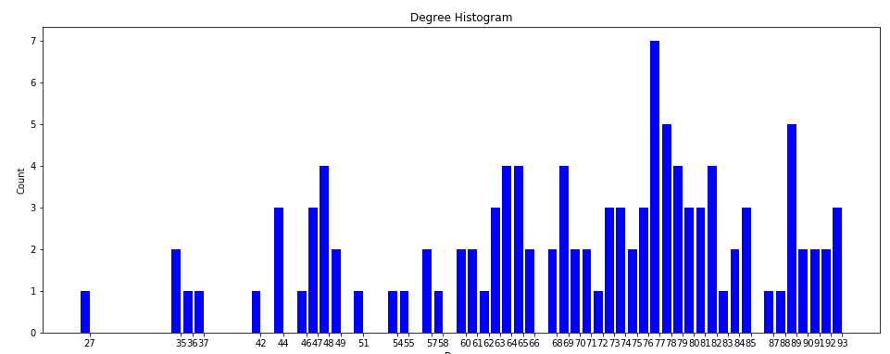

However, if we remove non-foragers from the graph entirely and re-compute the degrees, we get the following histogram:

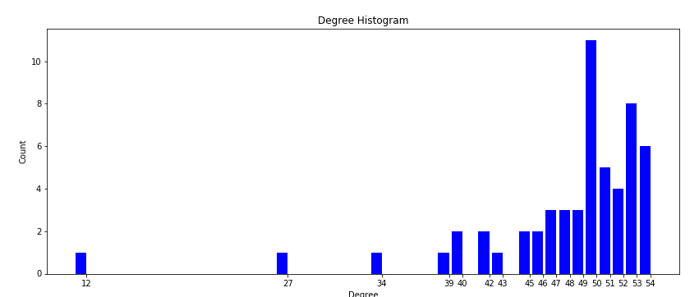

Breaking this down by percent rather than count, we get the following histogram:

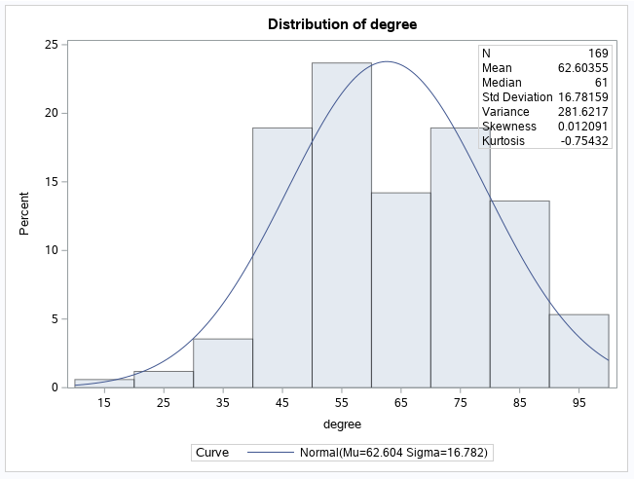

The Probability Plot for degrees is as follows:

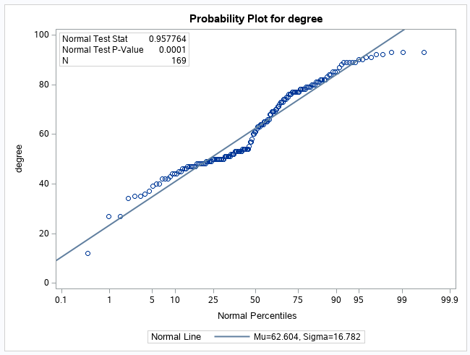

SAS gives us the following value for Goodness-of-Fit Tests for the Normal Distribution:

**Fitted Normal Distribution for degree**

| **Goodness-of-Fit Tests for Normal Distribution** | | | | |
| --- | --- | --- | --- | --- |
| **Test** | **Statistic** | | **p Value** | |
| **Kolmogorov-Smirnov** | **D** | 0.15153301 | **Pr > D** | <0.010 |
| **Cramer-von Mises** | **W-Sq** | 0.54601769 | **Pr > W-Sq** | <0.005 |
| **Anderson-Darling** | **A-Sq** | 2.95194971 | **Pr > A-Sq** | <0.005 |

This suggests that the data is not, in fact, normal (since p < 0.05 and the null hypothesis is that the data is normally distributed), but it’s not nearly as far off from normal as the previous data set. In particular, in the normal distribution, skewness is approximately 0, which is the case here; however, kurtosis is 3 in the normal distribution (as opposed to -0.75 in this case). Thus, this has more “tailedness” than a strictly normal distribution.

Additionally, the average clustering is approximately 0.9152 and the average shortest path length is approximately 1.1253 with a standard deviation of approximately 0.3249. By way of comparison, a Watts-Strogatz Graph with 163 nodes, mean of 61, and a p of 0.5 has an average shortest path length of approximately 1.62963 (with a standard deviation of 0.4973) and average clustering coefficient of 0.3798. A t-test shows a p-value of approximately $4.4673*{10}^{-23}$, showing that there is a statistically significant difference between the average path lengths of the two graphs. (Similar computations were not performed for clustering coefficient). The fact that the clustering coefficient for our graph is higher than the clustering coefficient of a Watts-Strogatz Graph (which has been shown to have the small-world property) and the average path lengths are statistically significantly lower, this suggests that our network also has very strong small-worldedness.

Full code for these calculations can be found in the accompanying Jupyter Notebook.

We can further infer from this that transitions will occur when a quiescent forager has a minimum of two neighbors in a 20-second period who have successfully returned from foraging – in other words, a vertex with a negative spin will change to having a positive spin if, and only if, two or more of its neighbors also have a positive spin. (The number of neighbors that have a negative spin makes no difference as to when the transition occurs). We can also assume that successful foragers who recently encountered a quiescent forager will soon put down the food, since quiescent foragers wait inside the nest to minimize water loss. (They may, however, encounter multiple quiescent foragers before they do so; the exact number of quiescent foragers that they encounter will be normally distributed).

A shortcoming of this, of course, is that this data set does not distinguish between exactly what context the foragers encountered each other in. We will assume that, since overall forager interactions are normally distributed, interactions between successful foragers and quiescent foragers are also normally distributed. While this seems to be a reasonable assumption on the face of it, we must remember that this fact is not strictly guaranteed by the data set.

The first order of business is to determine what the terms in the equations supplied above even mean in this instance. What does “temperature” or “energy reduction” mean? Is there some sense in which the system is “more optimal” or consumes less “energy” when a higher number of foragers are performing the same task (i.e. their “spins” are aligned)? The answer appears to be “yes,” and the reason is the following: ant colonies have an overall energy and water expenditure and have a strong incentive to minimize waste (especially given the hot desert climate that Harvester Ants are subject to). If other foragers are successfully locating food, more foragers should leave the nest; otherwise, fewer. (We must, however, be very careful to avoid circular reasoning, since one of the key questions of this project is the optimal rate for leaving the nest for foragers).

As further evidence that this is the case, ants appear to consciously try to recruit other ants for tasks (see Gelblum, A., Pinkoviezky, I., Fonio, E., Ghosh, A., Gov, N., & Feinerman, O. (2015). Ant groups optimally amplify the effect of transiently informed individuals. *Nature communications*, *6*, 7729. <https://doi.org/10.1038/ncomms8729>). This suggests that coordination on certain tasks is optimal.

The rate of active foragers transitioning to quiescent foragers will be the total time of the trip outside the nest, however long it takes them to find the food, and some number of seconds inside the nest. It will take 20 – 30 seconds on average for a quiescent forager to become an active forager after the next. [CITATION?]

The average foraging range is 25 – 30 square meters (Gordon, D. M. 1995. The development of an ant colony’s foraging range. Anim. Behav. 49: 649-659.)

In terms of speed of foragers, two major factors are food size and temperature, with larger food size and temperature both increasing total time. (Body size, however, does *not* have a statistically significant effect on forager speed). On average, though, red harvester ants (*P. barbatus*) trips took an average of 13.1 minutes, with the outbound trip taking 2.3 minutes on average, the inbound trip taking 2.6 minutes on average, and the food search taking 8.4 minutes on average. The distance of the inbound trip was, on average, 5.4 meters. (Morehead, S. A., & Feener, D. H., Jr. (1998). Foraging behavior and morphology: seed selection in the harvester ant genus, Pogonomyrmex. *Oecologia*, *114*(4), 548–555. https://doi.org/10.1007/s004420050479)

The energy saving is a function of the following: water loss rate due to sun and energy expenditure during foraging. Consider a simple colony that consists of two foragers. If both foragers have a negative spin (i.e. are quiescent), they have significantly diminished water loss rate and energy expenditure (but that will never be 0 because all organisms consume water and calories merely in the course of the day[1]). However, they will not retrieve any food. This would occur if, for example, they “gave up” on finding food. On the other hand, if one is active and the other is not (i.e. one has a positive spin and the other has a negative spin – their spins are *not* aligned), that presumably means that they have not successfully brought food back and are actively looking for it, which incurs the “full” energy penalty for the duration of their unsuccessful foraging. If both are foraging (i.e. they both have a positive spin), then they will get food at a fraction of the cost of both wondering around aimlessly. It will take merely the cost of the round-trip with food, without any of the “wandering around.” For simplicity, let us assume that the cost of this state is 0.25 the cost of the unaligned state:

$$H=-\sum_{i≠j}{0.25σ_{i}σ_{j}}$$

assuming that $σ_{i}$ and $σ_{j}$ are both positive.

This introduces a problem: if the state where both spins are positive is higher energy than a state where both are negative, then wouldn’t the system tend towards the negative spins in the thermodynamic limit? In this case, our system would predict that, if all ants temporarily stopped foraging for some reason, there would be no way for them to start foraging again. This is decidedly *not* true.

One solution is that successful introduces energy from outside. Indeed, in an Ising Model in statistical physics, a system can be attached to an external heat bath.

If we wanted to calculate the equilibrium, we would need to find a way to compute the temperature of the system. Recall that the formula for the equilibrium is:

$$P_{eq}\left(σ\right)=\frac{exp⁡(-\frac{H\left(σ\right)}{k_{B}T})}{Z}$$

It is not immediately obvious what the temperature of the colony means. However, the fact that the unit of this is joules provides a significant clue: there *are* ways to provide a meaningful energy state in joules for the foragers. The most logical value for this is the total approximate energy expenditure of the colony in joules. (We could also use the energy of their food stores in joules, or the net energy of the colony by subtracting the energy expenditure of the colony from the total energy stores).

The net energy of foragers at any given time is:

$$E_{net}=P_{quiescent}E_{quiescent}+P_{search}E_{search}+P_{outbound}E_{outbound}+P_{inbound}E_{inbound}$$

subject to the constraint that $P_{quiescent}+P_{active}+P_{search}+P_{outbound}+P_{inbound}=1$. We have already calculated that outgoing trips take 2.3 minutes on average, searching takes 8.4 minutes, and inbound trips take 2.6 minutes for a total of 13.3. This is fairly similar ($≈87.79\%$) to a finding described below in which a related species of ant foraged for 15.15 minutes on average in an experimental apparatus.

Note that the result for $E_{net}$ will vary by colony. In particular, foragers appear to be less active in larger colonies than in smaller colonies, which results in energy consumption of colonies scaling sublinearly with size.

Ferral, N., Holloway, K., Li, M., Yin, Z., & Hou, C. (2017). Heterogeneous activity causes a nonlinear increase in the group energy use of ant workers isolated from queen and brood. *Insect Science*, *25*(3), 487–498. https://doi.org/10.1111/1744-7917.12433

According to a study by J. H. Fewell on a different species of harvester ant, *Pogonomyrmex occidentalis*, energetic costs for foraging ants are less than 0.1% of the caloric rewards of harvested seeds. Furthermore, ants appear to prefer to maximize time efficiency rather than energy efficiency due to high food to energy ratio. In this study, the author obtained metabolic rate data by measuring ants’ oxygen consumption in a sealed glass environment that was set up to be free of carbon dioxide. Inactive ants had an average metabolic rate of 1.215 ml $\frac{O_{2}}{g}h$, vs. 1.846 ml $\frac{O_{2}}{g}h$ for walking ants, suggesting that inactive ants consume $≈65.82\%$ as much energy as foraging ants. Ants walked at an average rate of 1.11 m/min in the experimental apparatus (vs. 1.35 m/min in field measurements).

Fewell, J. H. (1988). Energetic and time costs of foraging in harvester ants, Pogonomyrmex occidentalis. *Behavioral Ecology and Sociobiology*, *22*(6), 401–408. https://doi.org/10.1007/bf00294977

Additionally, the study found that 59.4% of the trip distance was travel to the food source and 40.6% was made while returning with the food. The mean weight of the items was 8.07 mg, which was 120% of the mean weight of the ants (6.02 mg). The weight increased metabolic rate by 1.62 times in another study cited by the author, which was not re-tested for this study.

An additional 1.45 minutes was spent handling food items before returning, which was not directly measured but was assumed to be equal to the measured oxygen consumption during seed handling.

The mean energy cost per foraging trip was estimated to be 0.088 joules.

In the field, the number of seeds collected varied by whether the routes they followed were cleared (an average of 18.31 seeds per ant per day, maximum 92) or not (an average of 9.69 seeds per ant per day, maximum 36).

Seeds have a benefit from seeds of 92.9 j based on a study from Kelrik and MacMhon:

Kelrick, M. I., & MacMahon, J. A. (1985). Nutritional and Physical Attributes of Seeds of Some Common Sagebrush-Steppe Plants: Some Implications for Ecological Theory and Management. *Journal of Range Management*, *38*(1), 65. https://doi.org/10.2307/3899336

Ants in the apparatus walked for an average of 15.15 minutes and were inactive for an average of 6.06 minutes, indicating that ants on average spent $≈71.43\%$ of their time foraging and $≈28.57\%$ of their time inactive.

Fewell, J. H. (1988). Energetic and time costs of foraging in harvester ants, Pogonomyrmex occidentalis. *Behavioral Ecology and Sociobiology*, *22*(6), 401–408. https://doi.org/10.1007/bf00294977

In this author’s study, the success probability was 75% for ants on lower cover routes and 50% for ants on vegetated rates. However, for Red Harvester Ants, D.M. Gordon has found that Red Harvester Ant foragers tend to forage until they find food, with 90% of them foraging until they are successful.

Gordon, D. M. (1991). Behavioral Flexibility and the Foraging Ecology of Seed-Eating Ants. *The American Naturalist*, *138*(2), 379–411. https://doi.org/10.1086/285223

cited in

Schafer, R. J., Holmes, S., & Gordon, D. M. (2006). Forager activation and food availability in harvester ants. *Animal Behaviour*, *71*(4), 815–822. https://doi.org/10.1016/j.anbehav.2005.05.024

Knowing these facts, we can rewrite the previously-stated equation to simply reflect the proportion of the time that they forage. On Sunday, June 6, 2021, sunrise in Phoenix, AZ was 5:18 AM and sunset was 7:35 PM for a total day length of 14:17:43. Converting to seconds, we have

$$\left(14*60*60\right)+\left(17*60\right)+43=51463 seconds$$

in a day. A “cycle” of rest and inactivity is

$$\left(15.15*60\right)+\left(6.06*60\right)=909+363.6=1272.6 seconds$$

This means that an ant could, on average, complete

$$\frac{5143}{1272.6}≈40.44$$

trips per day. The total energy expenditure for each forager, then, is:

$$\left(0.7143*0.088*40.44\right)+\left(0.2857*\left(0.6582*0.088\right)*40.44\right)≈3.21 J$$

For a colony of 2000 foragers, this is approximately 6422.41 joules. (Note that I did *not* include the energy expenditure of other types of ants, such as queens and nurses).

*Sunrise and sunset time, day length in Phoenix, Arizona, USA*. Sunrise and sunset time, day length in Phoenix, Arizona, USA today and for the current month. (n.d.). https://dateandtime.info/citysunrisesunset.php?id=5308655.

Thus, we will find that $k_{b}T=6422.41 J$ for the entire day (since the Boltzmann Constant, which is $1.380679*{10}^{-23}\frac{J}{K}$, serves primarily to relate the average kinetic activity of particles of gas to the thermodynamic temperature). **Citation:** Wikipedia contributors. (2021, June 2). Boltzmann constant. In *Wikipedia, The Free Encyclopedia*. Retrieved 19:47, June 6, 2021, from <https://en.wikipedia.org/w/index.php?title=Boltzmann_constant&oldid=1026393161>

Next, recall that $$H=-\sum_{i≠j}{0.25σ_{i}σ_{j}=-\left(0.25*3.21\right)=-0.8025 J}$$

Next, we need to calculate Z, which is a normalization factor that sums over every possible state:

$$Z=\sum_{σ}{exp⁡(-H\left(σ\right)/k_{B}T})≈\exp\left(-\frac{-0.8025J}{0.6692 J}\right)+\exp\left(-\frac{-0.8025}{2.542}\right)=\exp\left(1.1992\right)+\exp\left(0.3157\right)≈4.6655$$

Note that we have used the energies for the individual ants for an individual trip (rather than the energy values for the entire colony for a day). Thus, for our hypothetical two-ant system, the probability that both of them will be inactive foragers in equilibrium is:

$$P_{eq}\left(σ\right)=\frac{exp⁡(-\frac{H\left(σ\right)}{k_{B}T})}{Z}=\frac{exp⁡(-\frac{-0.8025J}{0.6692 J})}{4.6655}=\frac{exp⁡(1.1992)}{4.6655}≈\frac{3.294}{4.6655}≈0.7061$$

The probability of them both being active foragers is:

$$P\left(σ^{'}\right)=\frac{\exp\left(0.3157\right)}{4.6655}≈0.2939$$

We can easily verify that $0.7061+0.2939=1$, which is to be expected. This immediately introduces a problem: this appears to be “inverted” – we had observed that foragers are active 71.43% of the time and inactive 28.57% of the time. In fact, these appear to be exactly “flipped”. It turns out that the thermodynamic equilibrium, of course, prefers the *lower* energy solution (whereas we have set the foragers to be the higher energy state). If we simply reverse these numbers, the model becomes fairly close to the actual proportions of foragers and non-foragers that were observed experimentally. This suggests that harvester ant foraging is, in fact, close to a mathematical equilibrium.

To see what this can tell us about why Red Harvester Ants might “swarm” over food, recall that a high rate of successful return signals that foragers are likely to be successful. We have stated above that an ant searches, on average, for 8.4 minutes for food. Suppose that a large number of successful ants signals readily available food – in fact, let us suppose that it’s so readily available that it would only take ants 30 seconds to find food instead of 8.4 minutes. Then the total time is the outbound trip + the lower search time + the inbound trip, which results in a foraging trip having a cost of

$$\frac{2.3+2.6+0.5}{2.3+2.6+8.4}*0.088≈0.406*0.088 J=0.03573 J$$

We will recompute the total cost for a day of foraging at this rate:

$$\left(0.7143*0.03573*40.44\right)+\left(0.2857*\left(0.6582*0.03573\right)*40.44\right)≈1.30 J$$

And the Hamilton: $$H=-\sum_{i≠j}{0.25σ_{i}σ_{j}=-\left(0.25*1.30\right)=-0.325 J}$$

We further note that the total energy consumption for 2000 foragers is 2600 J (2064 of which is while they’re active and the rest of which is while they’re inactive). This is obviously a *significant* cost saving.

We will recompute $Z$ at

$$Z=\sum_{σ}{exp⁡(-H\left(σ\right)/k_{B}T})≈exp\left(-\frac{-0.325}{1.03}\right)+exp\left(-\frac{-0.325}{0.2717}\right)≈\exp\left(0.3155\right)+\exp\left(1.1962\right)≈4.67847$$

Thus, the equilibrium for state 1 becomes:

$$P_{eq}\left(σ\right)=\frac{exp⁡(-\frac{H\left(σ\right)}{k_{B}T})}{Z}=\frac{exp⁡(-\frac{-0.325 J}{2064 J})}{4.67847}=\frac{exp⁡(0.0001575)}{4.67847}≈\frac{1}{4.67847}≈0.2137$$

We can compute $P_{eq}(σ^{'})$ as:

$$P_{eq}\left(σ^{'}\right)=1-0.2137≈0.7863$$

As described above, we need to “reverse” these and find that 78.63% of the foragers are active and 21.37% of the foragers are inactive. Thus, this model predicts that it *is*, in fact, globally optimal for ants to “swarm” over food because it results in an improved energy profile for the colony as a whole. Thus, the

Data collected by Gordon *et. al.* of 49 consecutive 5-second intervals of a collection of ants

1. Humans, for comparison, burn 90 – 150 calories per hour merely sitting. Processes like respiration, digestion, circulation, brain activity, vision, etc. continue at all times. Activities like typing, talking, and even sitting upright require complex patterns of muscle activation; for example, humans have a large number of muscles involved in keeping the spine upright, which are “rotated” in order to avoid excessive fatigue.